**DEMO NOTES**

**1. WHAT IS DATABASE?** PLATFORM TO STORE ANY AMOUNT OF DATA. SECURED. FASTER.

**2. WHAT IS DBMS ?** DATABASE MANAGEMENT SYSTEM

A SOFTWARE USED TO STORE AND MANAGE DATABASES.

EXAMPLES FOR DBMS: SQL SERVER, DB2, ORACLE, SYBASE, INGRES

**3. WHAT IS SQL SERVER?** A **DBMS** SOFTWARE TO STORE DATABASES OF ANY SIZE.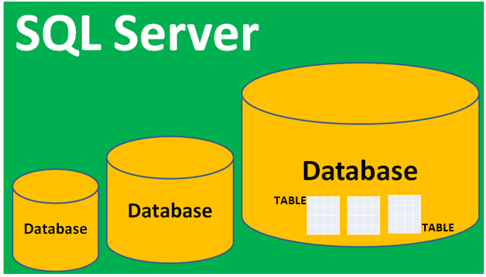

**4. WHY SQL SERVER?** CHEAPER (14500 USD) HIGHLY SCALABLE EASY USAGE

FREE SUPPORT FREE UPDATES FREE BI TOOLS

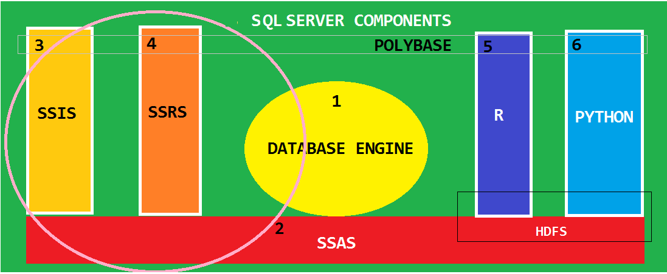

|  |  |  |
| --- | --- | --- |
|  | **Component** | **Purpose** |
| **1** | **Database Engine** | **Supports Real-time, Rapid Processing (OLTP) Databases** |
| **2** | **Analysis Services** | **Supports Analytical Databases for Big Data Analysis, Forecasts (OLAP)** |
| **3** | **Integration Services** | **Supports the Design of Databases for Old, Historical Data (DWH)** |
| **4** | **Reporting Services** | **For end to end implementation of Report Design, Storage, Access.** |
| **5** | **Machine Learning** | **Python and R. Used to implement Machine Learning for Data Scientists** |

**5. VERSIONS OF SQL SERVER?** **SQL SERVER 2019, SQL SERVER 2017, SQL SERVER 2016**, 2014, 2012.....

**6. EDITIONS OF SQL SERVER?** DATA CENTER, **ENTERPRISE, EVALUATION, STANDARD, DEVELOPER....**

**7. WHAT IS SQL?** A COMMON LANGUAGE TO COMMUNICATE WITH ANY DATABASE.

**8. WHAT IS T-SQL?** **TRANSACT SQL. A TYPE OF SQL USED FOR SQL SERVER DATABASES**

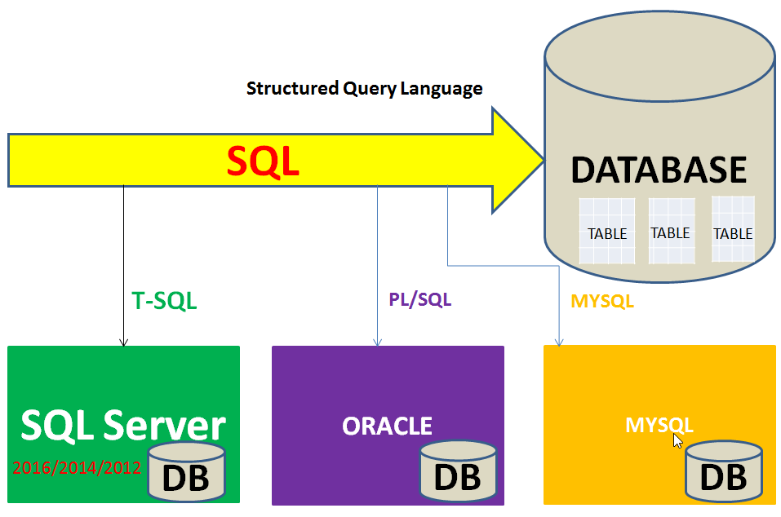

**9. WHAT ARE THE CAREER OPTIONS?**

|  |  |  |
| --- | --- | --- |
|  | **Job Profile** | **Job Roles** |
| **2** | **SQL Developers** | Design Databases to store LIVE, Real-time Data [OLTP : Online Transaction Processing Databases], Complex Queries & Programming. |
| **4** | **MSBI Developer** | Design Databases to store Historical Data, To perform Big Data Analysis, Forecasts and Reports. Involves Data Modeling and Data Formatting. |
| **6** | **Power BI Developer** | SQL Queries, Data Modeling, Report Design [Interactive Reports] in Cloud Paginated Reports, Analytical Reports, Mobile Reports in Report Server |
| **8** | **SQL DBA** | Database Management and Monitoring of Jobs, HA – DR & Alerts.  HA DR, Security Management. Involves Azure Cloud Admin, Power Shell |
| **9** | **Data Analysts and Data Scientists** | Implement BI Technologies with SQL for Data Gathering, Artificial Intelligence (AI), Machine Learning Algorithms, Natural Language Processing (NLP), Cloud Data Storage, Hadoop Insight and Data Analytics. |